Please follow all the setting down below:

The main function of this plugin is move existing user from group to another group.

Please see the profile_field_test8 – Copy.csv in your email attachment.

|  |  |  |
| --- | --- | --- |
| group1 | group | result |
| Existed | Existed | Remove user from group1  Move user to ngroup |
| Existed | Not exist | Remove user from group1  Create a new group  Move user to ngroup |
| Not exist | Existed | Move user to ngroup |
| Not exist | Not exist | Create a new group  Move user to ngroup |
| Empty | Existed | Do nothing |
| Existed | Empty | Do nothing |
| Empty | Not exist | Do nothing |
| Not exist | Empty | Do nothing |
| Empty | Empty | Do nothing |

1. We have installed a new plugin called Automated User Group Movement in your test site.

https://perfeng2.test.pukunui.net/admin/plugins.php?updatesonly=0&contribonly=1

1. And this is the plugin setting.

CSV File Directory: please filled the path you want the plugin process your users to specific/New group.

CSV Processed File Directory: please filled the path (when users are successfully being moved to specific/New group, your file will be moved to this path)

Delete processed csv files after month(s): This setting will automate check the last updated time of file and remove the file that is expired from folder path “CSV Processed File Directory”.

<https://perfeng2.test.pukunui.net/admin/settings.php?section=local_movegroup_settings>

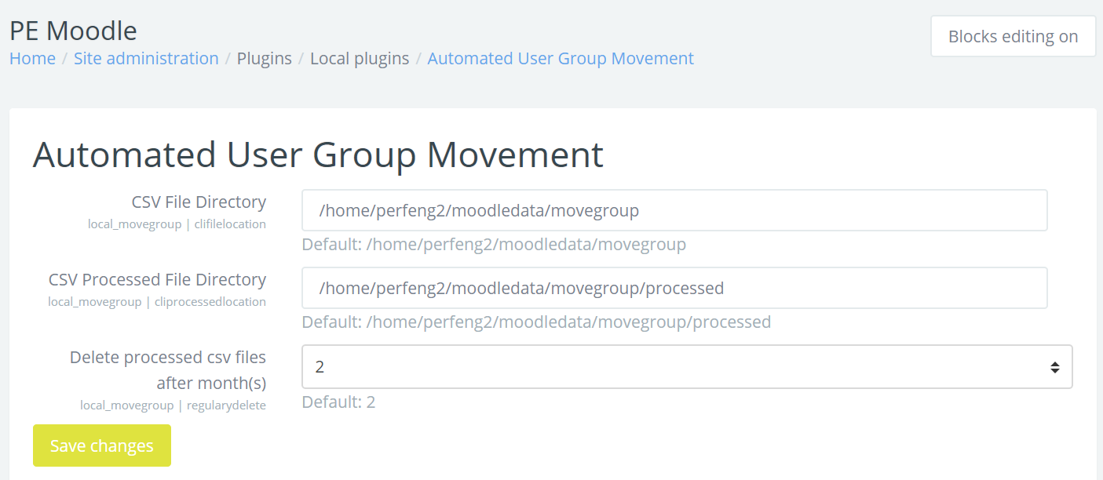

1. I used your existing course ABC – Australian Business Culture as a test course.

<https://perfeng2.test.pukunui.net/course/edit.php?id=29>

You can see I have done group moving test in this page.

I moved user Kantesh Kuppa DEVADIGA to New Group named Dom1

And moved user Pramodh RAJENDRAN to new Group Dom3

<https://perfeng2.test.pukunui.net/user/index.php?id=29>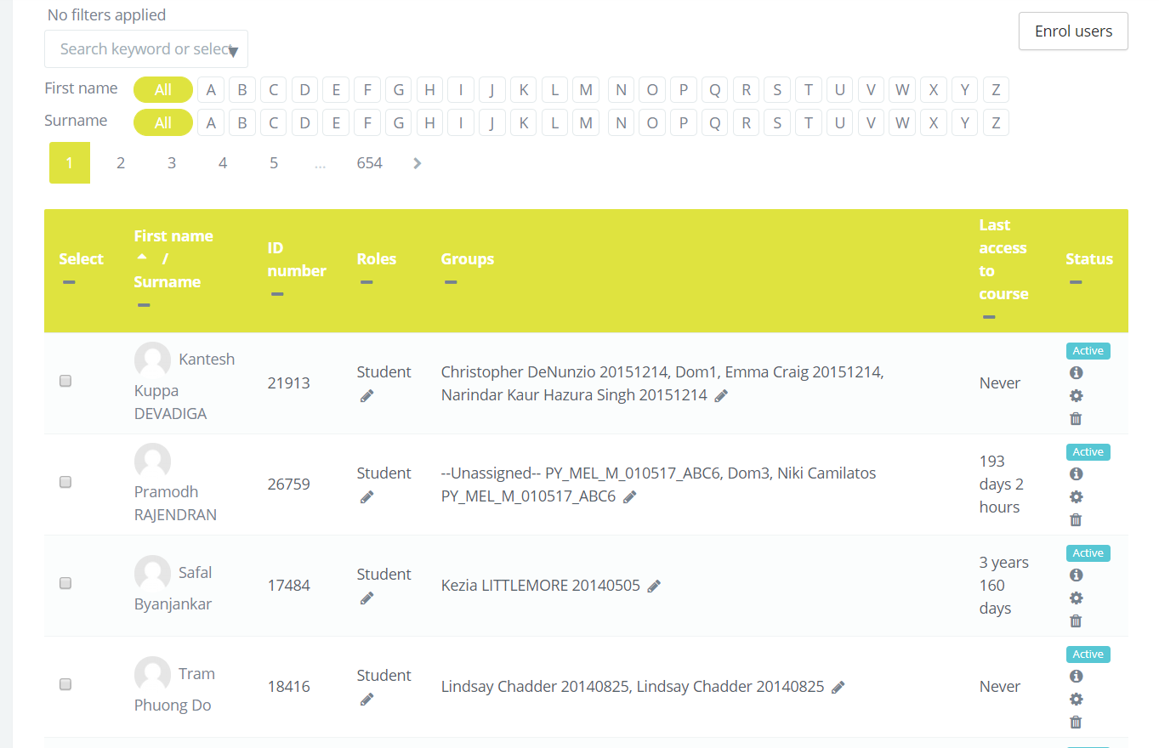

1. I have set 1 new Group named Ndom for those users in attachment csv file (profile_field_test8 – Copy.csv), you can test it, and follow the csv file fields to move the user to specific group by yourself.
2. Basically, you just need to set the path that file comes from and set the second path for your files to process, drop the csv file into the first path, and run the schedule tasks.

<https://perfeng2.test.pukunui.net/admin/tool/task/scheduledtasks.php>

